Name:________________ Date:_____________

The table below is from a sample from a larger data set collected on people discharged from a selected Pennsylvania hospital as part of a retrospective chart review of antibiotic usage in hospitals.

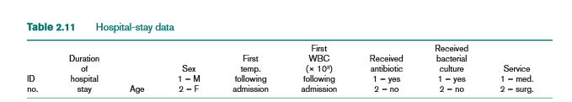

**Import the hospital dataset in the SAS to answer the questions below.**

**Question 1**. Run a linear regression model to determine where age has an linear effect on duration of stay in the hospital. Paste results from SAS here.

**Question 2**. What is the F-test statistics?

**Question 3**. What is the p-value from the F-test statistics?

**Question 4**. What is the conclusion for based on the p-value from the F test?

**Question 5**. What is the t-test statistics?

**Question 6**. What is the p-value from the t-test statistics?

**Question 7**. What is the conclusion for based on the p-value from the t test?

**Paste code here.**